Become informed! Visit

http://uwexcellence.org

Become informed! Visit

http://uwexcellence.org

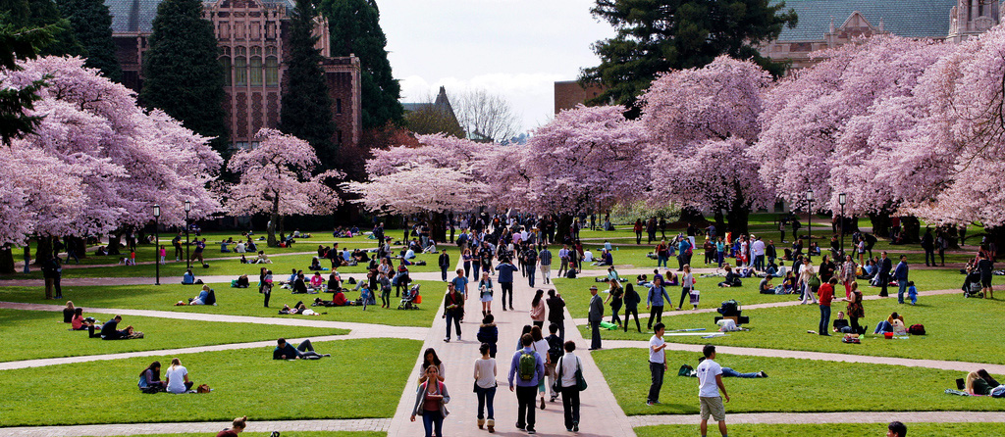
UW EXCELLENCE
http://uwexcellence.org
UW EXCELLENCE
http://uwexcellence.org
We are a group of University of Washington faculty members who deeply respect the historical role of organized labor in our nation, and acknowledge the current and future importance of unions for the protection of workers in many professions. But on the narrow question of whether UW faculty should be represented by the Service Employees International Union at this time, we have decided that we are opposed.
Become informed! Visit our website – http://uwexcellence.org
We are a group of University of Washington faculty members who deeply respect the historical role of organized labor in our nation, and acknowledge the current and future importance of unions for the protection of workers in many professions. But on the narrow question of whether UW faculty should be represented by the Service Employees International Union at this time, we have decided that we are opposed.
Become informed! Visit our website – http://uwexcellence.org

